Hydrogen in aluminium

Arild Håkonsen
07.05.2026

Introduction
Hydrogen is the only gas that is solvable in aluminium. The solubility is much higher in liquid aluminium than for solid aluminium. If the hydrogen content is too high in liquid porosity will form during solidification. The typical requirements of hydrogen content in the aluminium business for DC-cast products is less that 0,15-0,20ml H₂/100g Al. This is still above the solubility of solid alumnium, and thus may lead to some porosity, but considered acceptable.

The source of hydrogen
The source of hydrogen is normally moisture in the surrounding air or in refractory. Hydrogen (H2) is present in air but at very low amounts 0,5-0,6ppm. However, air normally contains much more hydrogen in water vapour. The amount of water vapour that can be absorbed by air is highly temperature dependent. The saturation of water in air is 17,3 g/m3 at room temperature, corresponding to ~14.300ppm water, [1]. This again corresponds to ~1600ppm H₂.
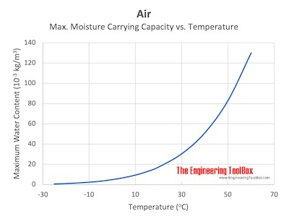
Figure 1. Water vapour saturation of air vs temperature.
Water vapour might react with liquid aluminium and make aluminium oxide and diatomic hydrogen-gas with the following reaction:
$3H_{2}O+2Al\overset{⇔}{}{Al}_{2}O_{3}+3H_{2}$ (1)
Some of this hydrogen gas might be dissolved as atoms in the liquid by the following reaction:
$H_{2}\overset{⇔}{}2\tilde{H}$ (2)

The solubility of hydrogen in aluminium
The solubility of diatomic gases in liquid metals is normally calculated using the Sievert’s Law, for hydrogen:
$S=K_{T}C_{alloy}\sqrt{P_{H_{2}}}$ (3)
S is the solubility of hydrogen in the melt, K_{T} is the temperature dependent solubility constant, C_{alloy} is a correction factor dependent on alloy composition (between 0 and 1, and 1 for pure aluminium) and P_{H2} is the partial pressure of hydrogen in the gas above the melt. (3) might be written on the following form, then the expression left of the square root is the solubility at 1 atmosphere pressure (see level) (P₀):
$\text{S=}K_{0}\text{exp[-}\frac{\text{ΔH}}{RT}\text{]}C_{alloy} \sqrt{\frac{P_{H_{2}}}{P_{H_{2}}^{0}}}$ (3)
Here K₀ is a constant, ΔH is the solubility enthalpy, R is the gas constant (8,314J/molK) and T is temperature. In this work we have used the constants provided by [2] for K₀ and ΔH, see Table 1. In Figure 2 the solubility is plotted at 1 atm pressure.
Table 1. Constants in the calculation of solubility constant.
Element | Liquid | Solid
K0, [mol/(m³P^{0,5})];[ ml/100g] | 4,891E-3 ; 419,8 | 7,824E-4 ; 67,14
ΔH, [J/mol] | 49534 | 57079

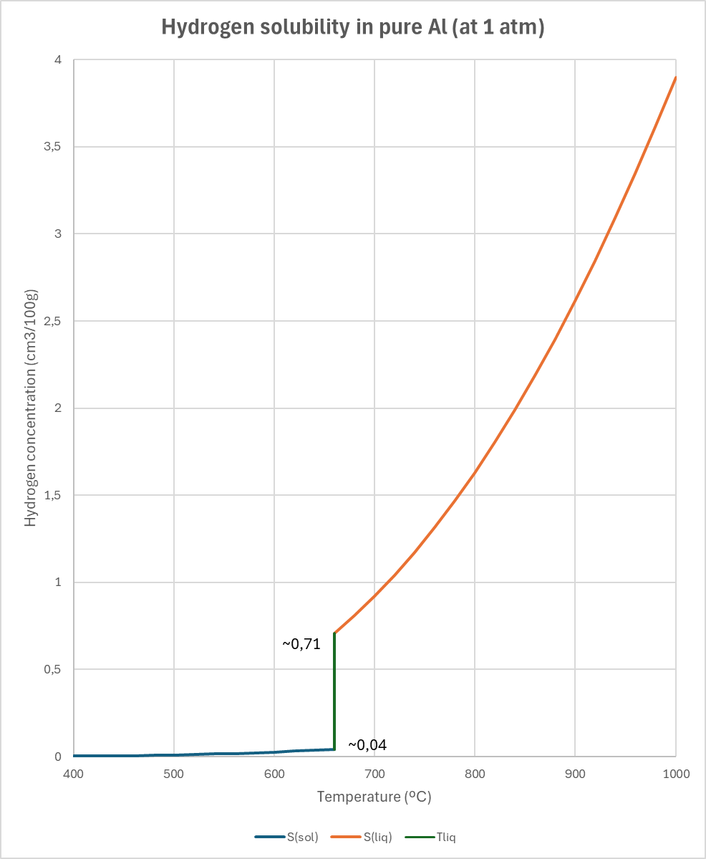
Figure 2. The solubility of hydrogen in pure aluminium at P=1 atm.
For the alloy dependent correction factor, we have used the equation, (4), and values proposed by Sigworth [3], given in Table 2:
Table 2. Correction factors for the calculation of C_{alloy} for alloying elements.
Element | e | r
Si | 0,03 | -0,0008
Mg | -0,01 | 0
Mn | 0,06 | 0
Cu | 0,03 | -0,0004
Fe | 0 | 0

$C_{alloy}\text{=}{10}^{-\sum{e∙C_{i}}-\sum{r∙}C_{i}^{2}}$ (4)
In Figure 3 the solubility in pure aluminium for different pressures are shown, and Figure 4 shows the solubility for some common alloys (at 1 atm).
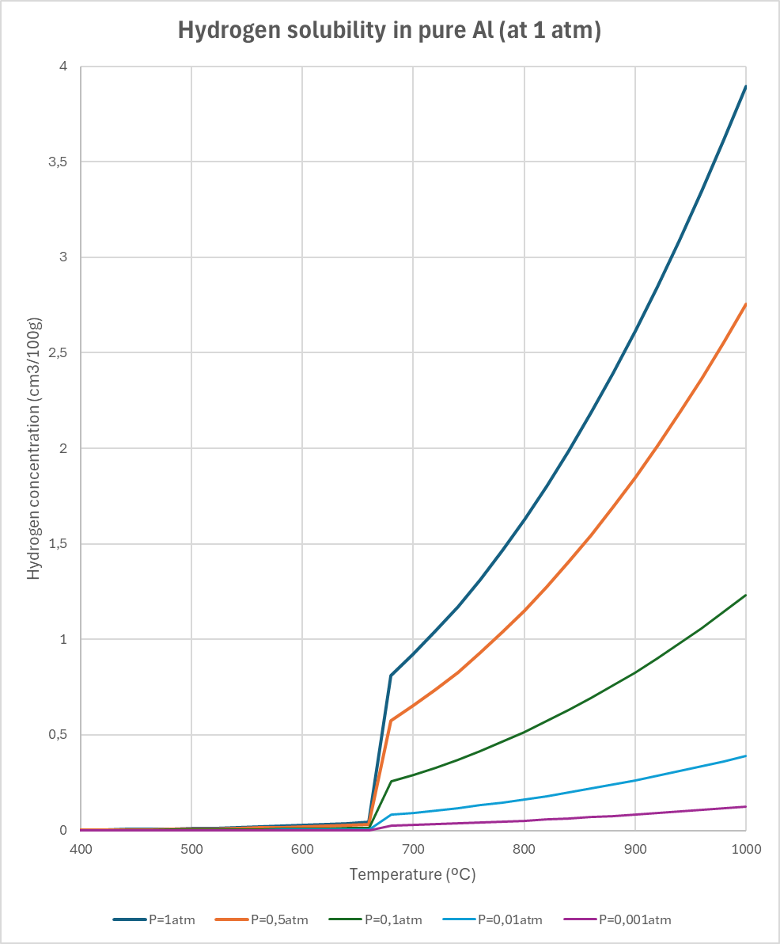
Figure 3. The solubility of hydrogen in pure aluminium at different pressure.
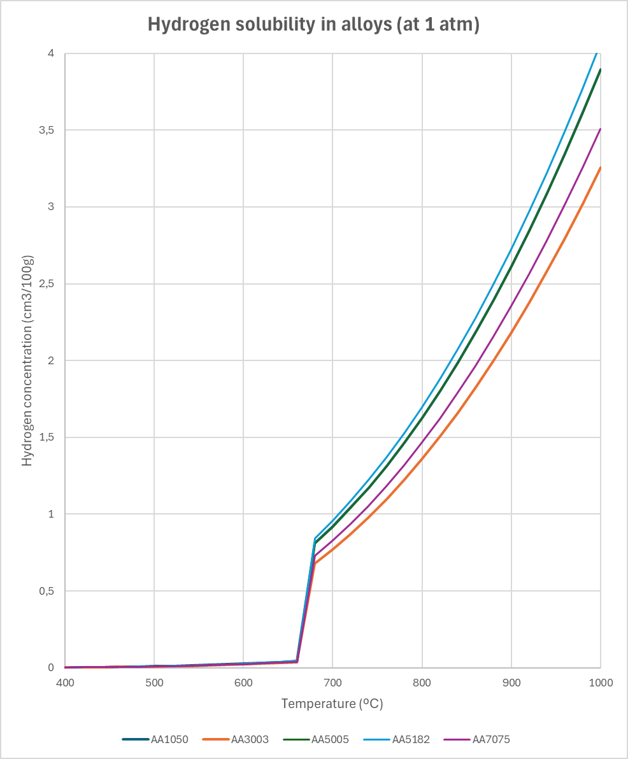
Figure 4. The solubility of hydrogen for some aluminium alloys at 1 atm pressure.

References
[1] https://www.engineeringtoolbox.com/maximum-moisture-content-air-d_1403.html
[2] Prince N. Anyalebechi, "Hydrogen Solubility in Liquid and Solid Pure Aluminum—Critical Review of Measurement Methodologies and Reported Values", Materials Sciences and Applications, 2022, 13, 158-212
[3] G.K. Sigworth: "Gas Fluxing of Molten Aluminum, Part 1: Hydrogen Removal," Light Metals 1999, 641-649.

